# VTS Browser JS Review regarding the 3d land-use site development.

## Pros

### looks fast.

### Polyline clamping on terrain is perfect.

### Styling for the clamped polyline layer is not bad. Better than expected.

<https://vts-geospatial.org/tutorials/geojson.html>

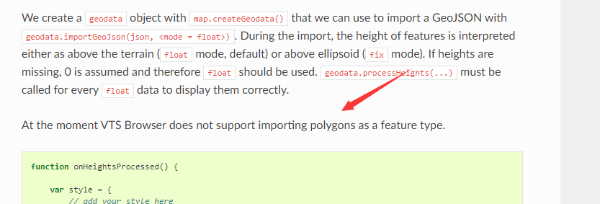

## Cons

### VTS does not support polygon importing from geojson.

### VTS does not support terrain exaggeration.

### Looks like it does not support imagery layer switching.

### Looks like it does not support multiple imagery layer overlapping.

### VTS does not support clipping.

### Melown Cloud.

According to the official document, we can configure the map by two methods.

* Melown Cloud (<https://melown.com/cloud>)
* make our own server

<https://vts-geospatial.org/tutorials/vtsbackend.html>

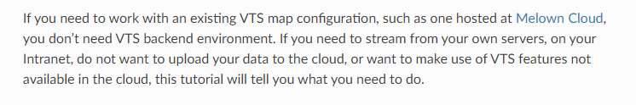

Melown Cloud(<https://melown.com/cloud>) looks similar to Cesium Ion.

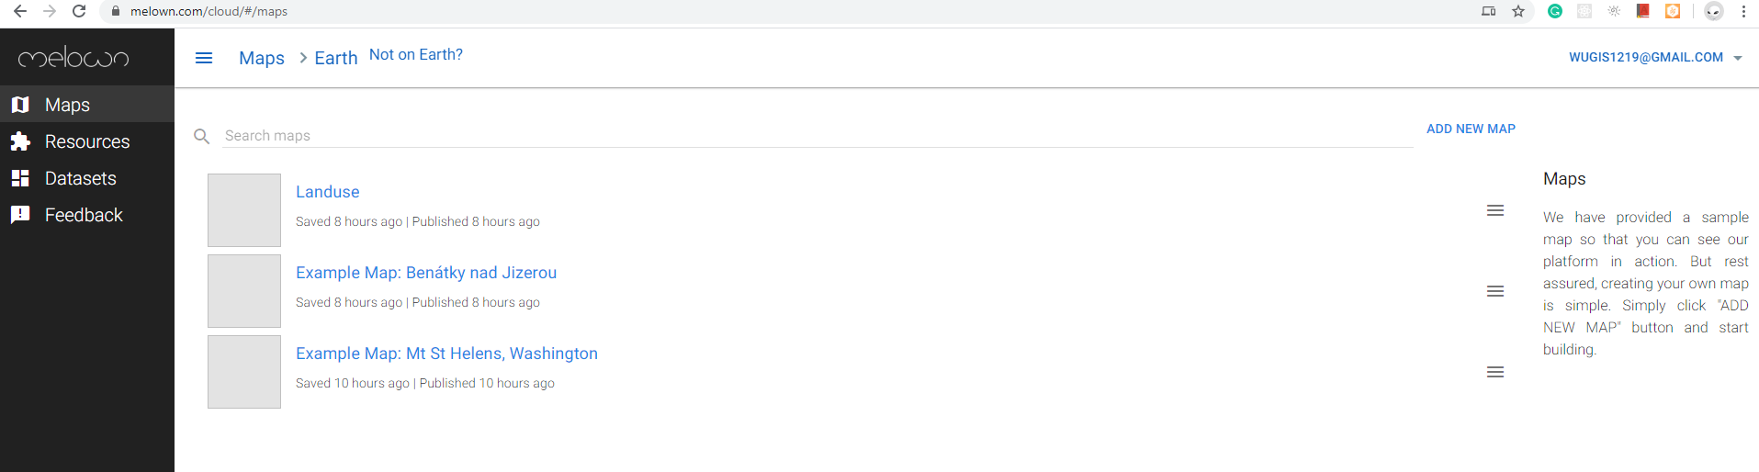

**Cons**

* Melown cloud does not support the uploading of a zip file.
* Uploading speed is very slow than Cesium Ion.

I am trying to upload 1.2 GB tif but can not guess when it will be finished.

It stops at 85% progress.

* Can not upload GEOJSON file.